mAadhar Application

**Source code:**

Main Github code: <https://github.com/kalviyarasi/AssistedProjects/tree/master/Capstone%20Project>

**Writeup:**

Create a spring starter project in eclipse.

Configure the database and port number.

Test your application with postman.

Create a project in visual studio code.

Connect it with eclipse code.

Run the eclipse project and run the angular project.

**Output screenshots:**

**Run the spring boot application**

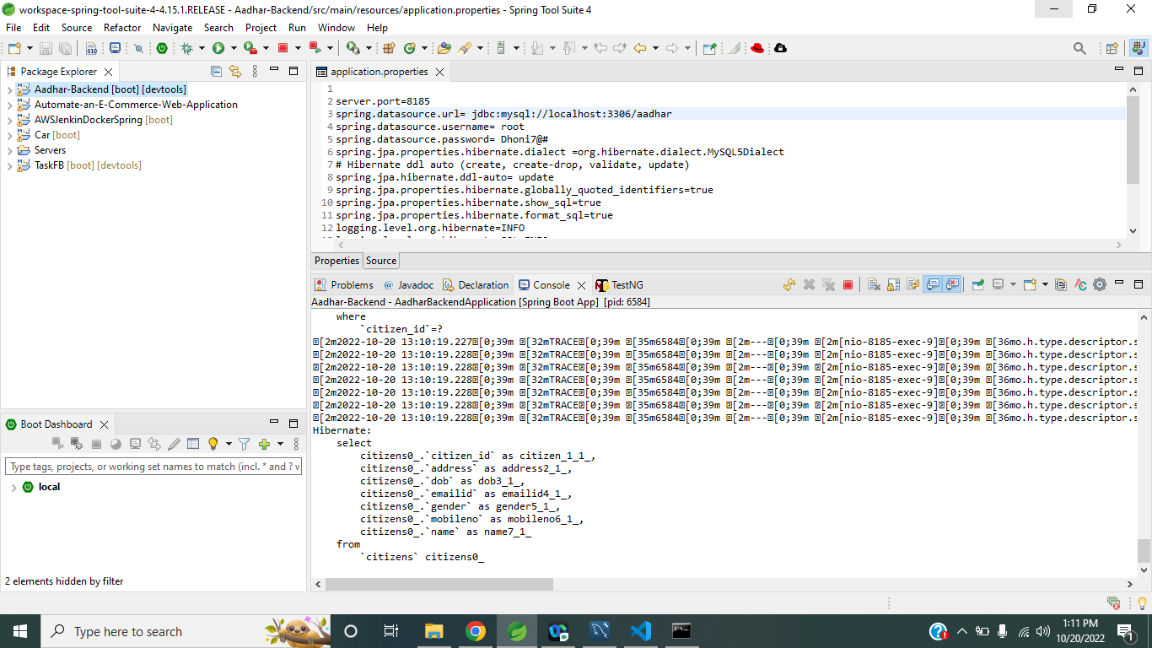

**Run the angular application**

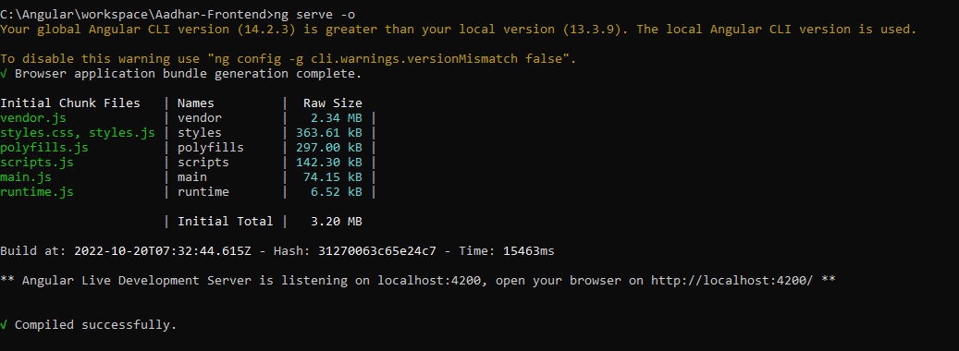

**Home page**

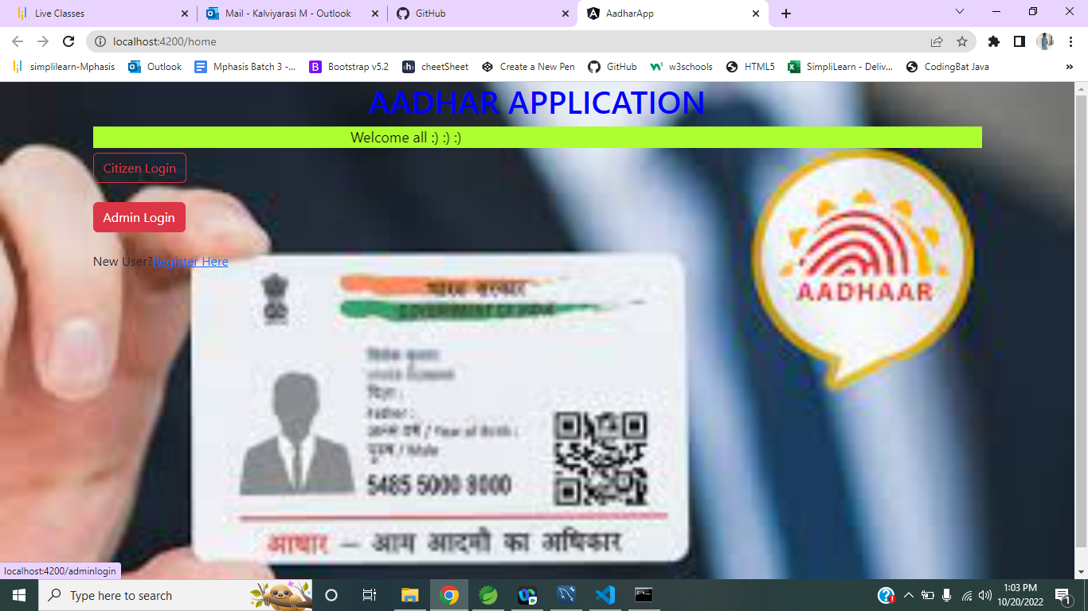

**Click register here**

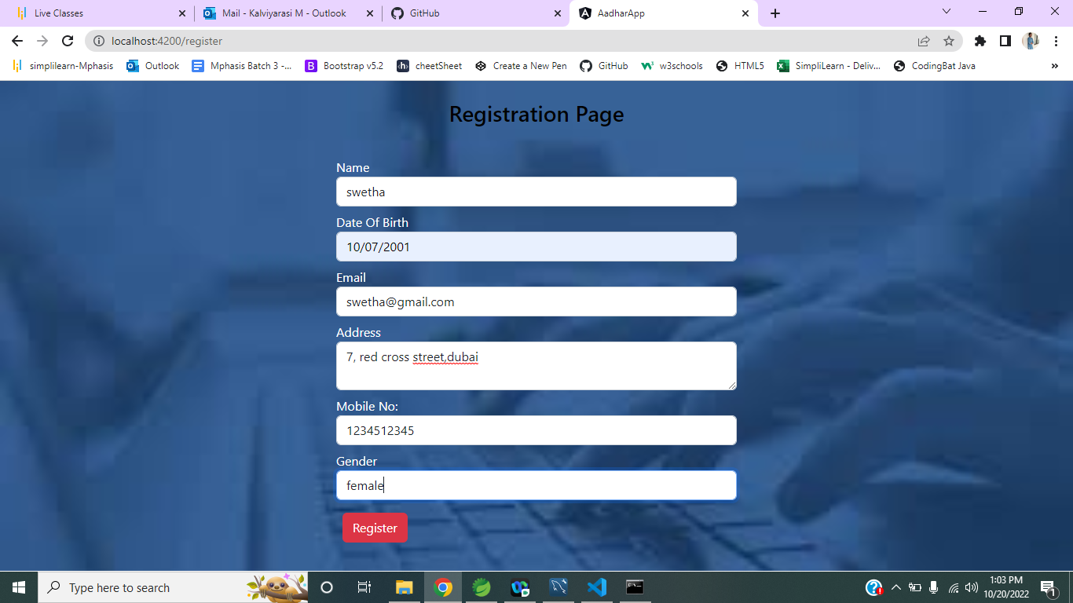

**Enter the details and click on register**

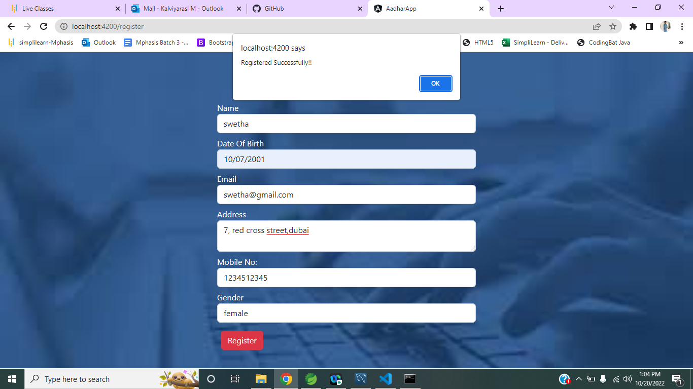

**Click on ok, now click on admin login**

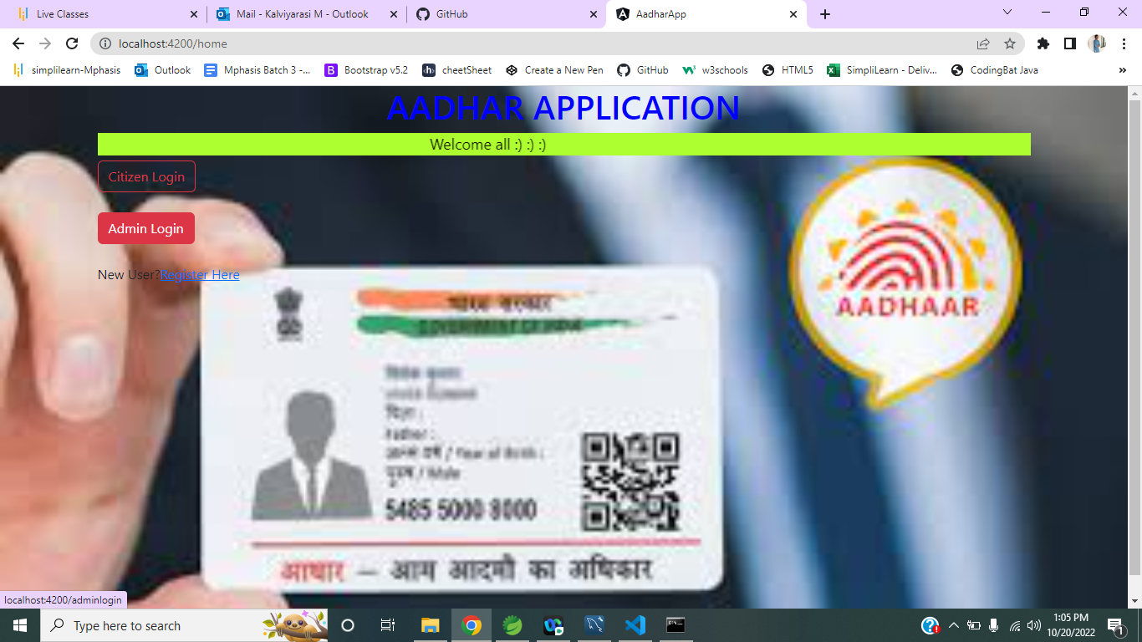

**Enter admin credentials**

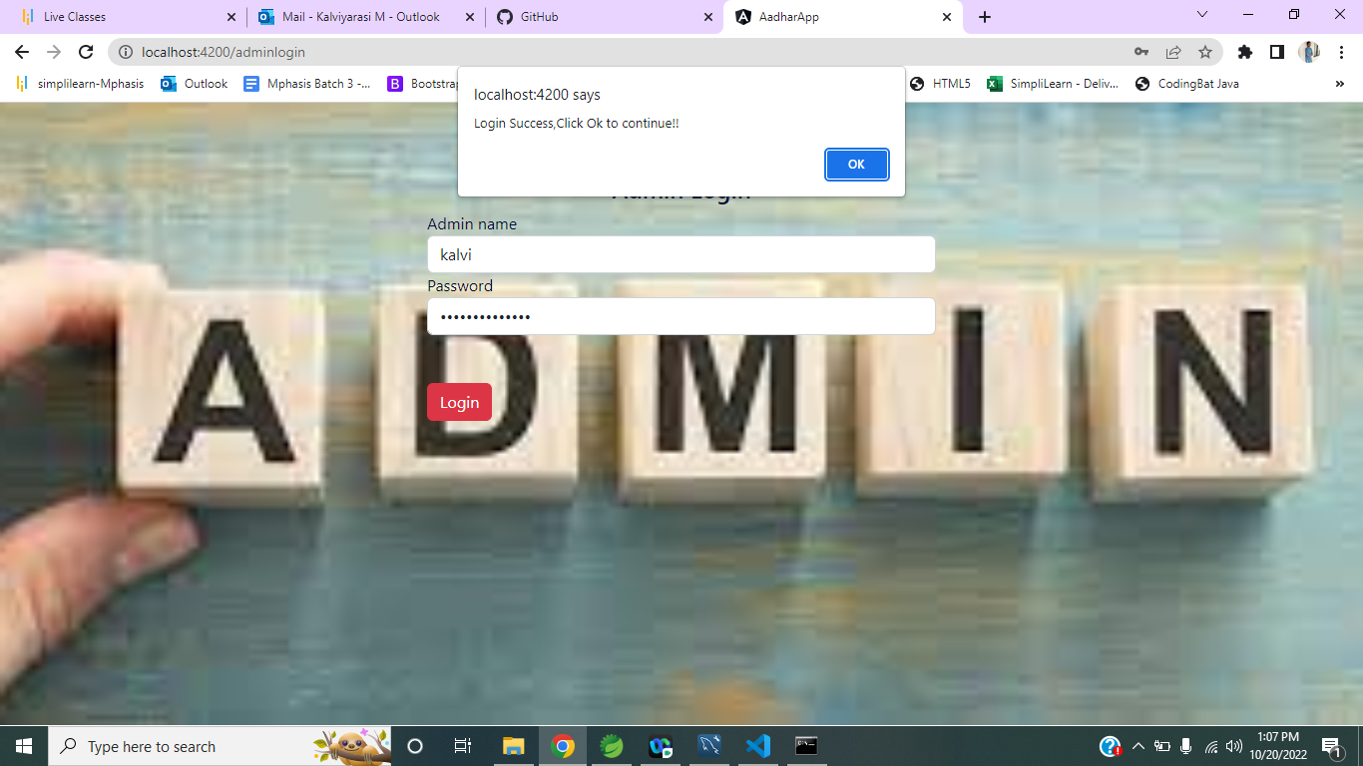

**Prompts to admin home page**

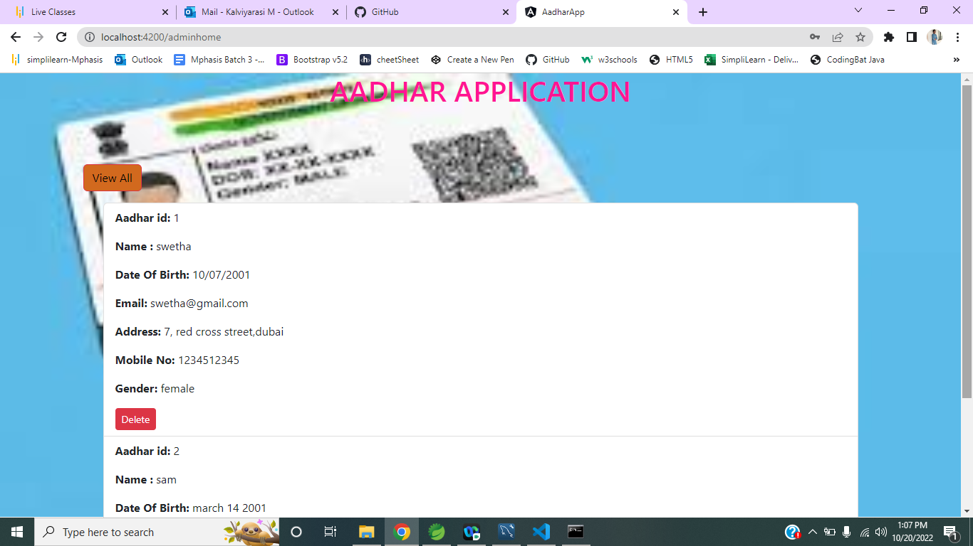

**Click on delete button**

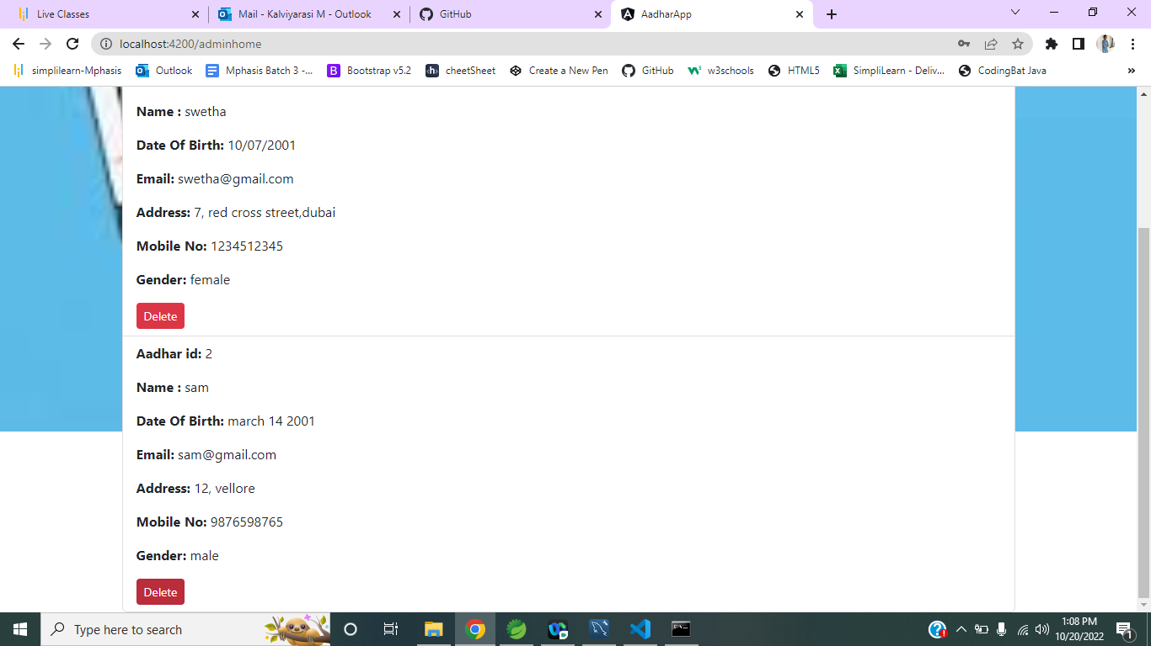

**Now see the updated details**

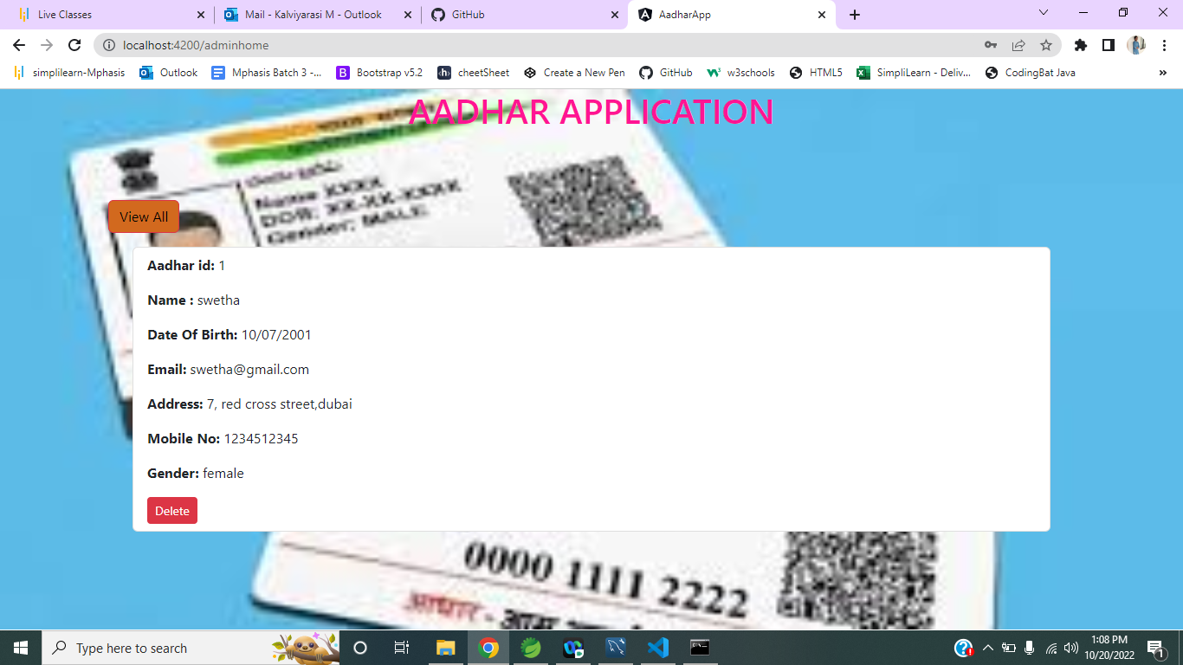

**Click on citizens**

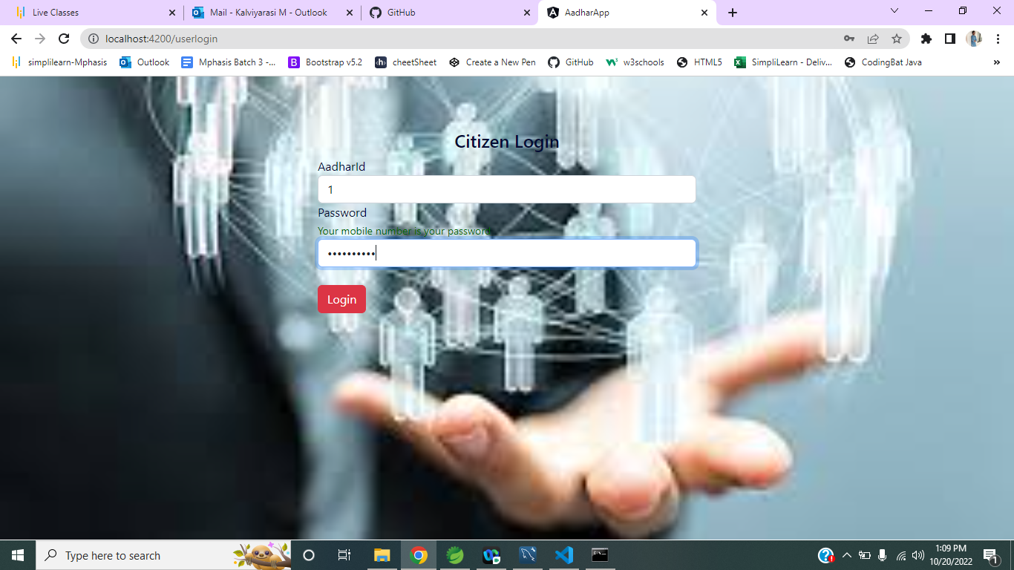

**Enter the details**

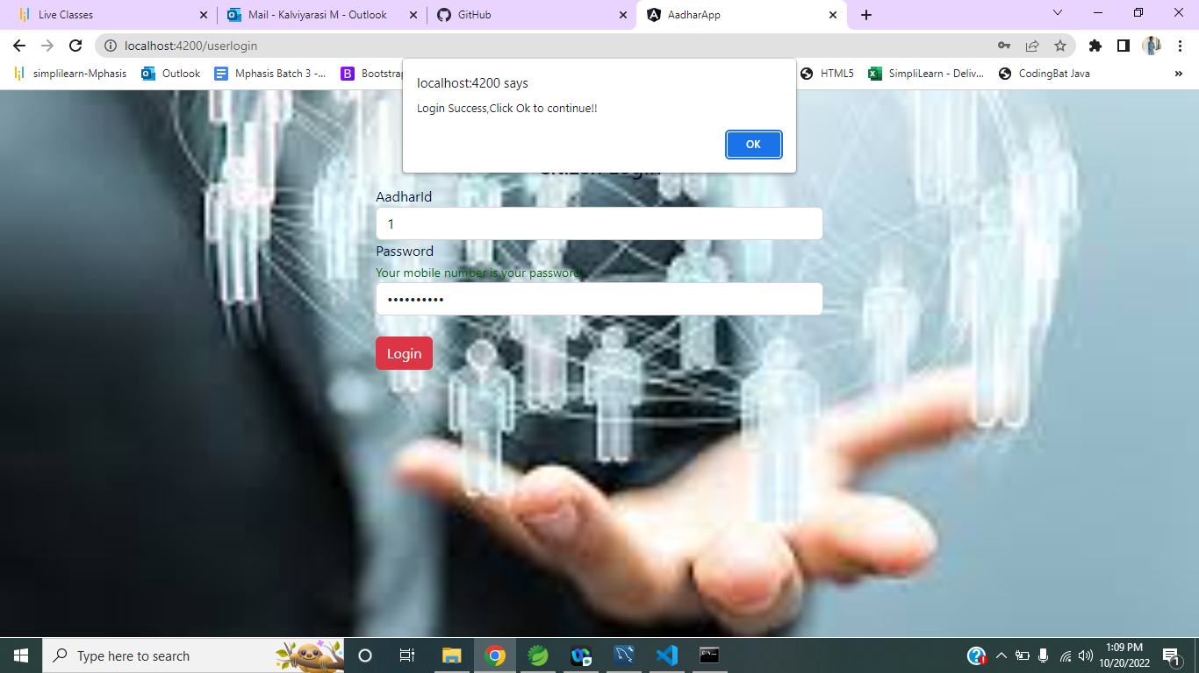

**Click on update to edit the details**

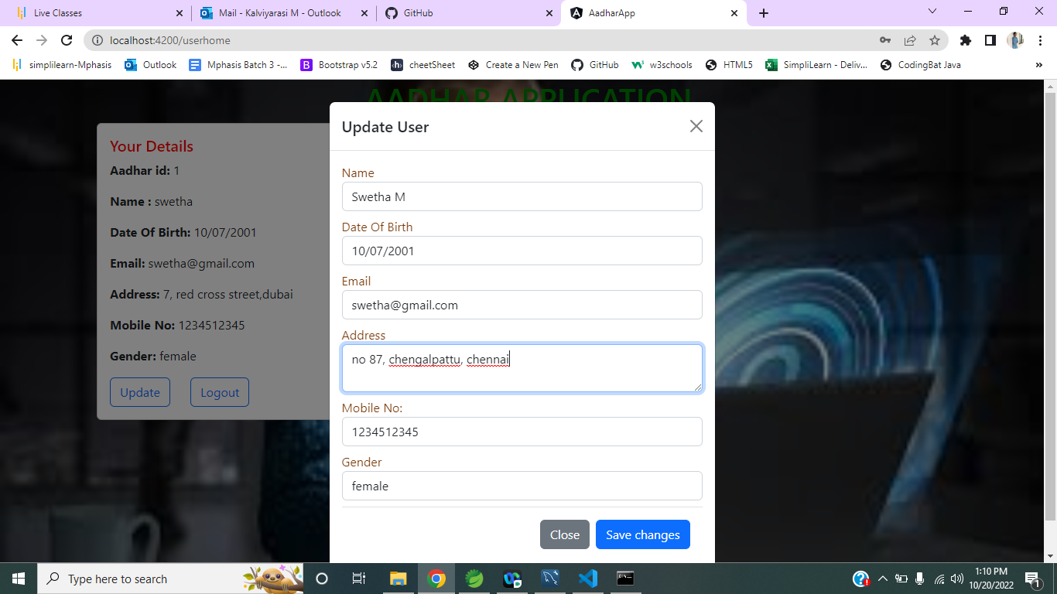

**Now could see updated details**

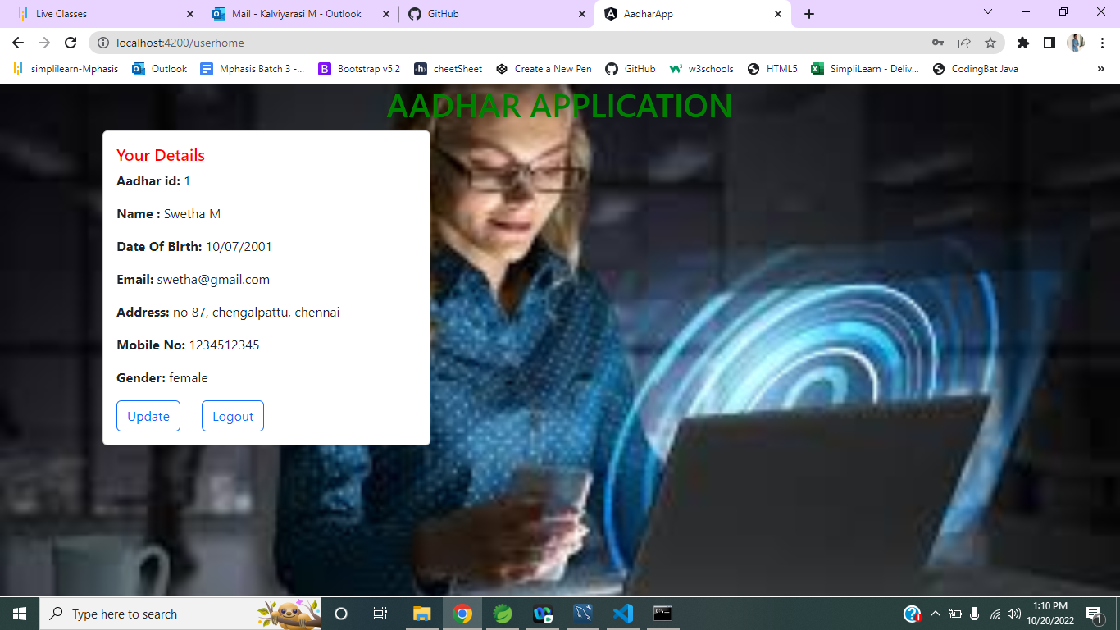

**Mysql**

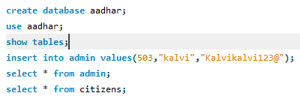

**The application is also tested for the automation using selenium and testNg**

